1. Which are the top three variables in your model which contribute most towards the probability of a lead getting converted?

Looking at the variables below **Lead Source_Welingak Website, Lead Source_Reference, what is your current occupation_Working Professional** where the variables which contributed the most of a lead getting converted.

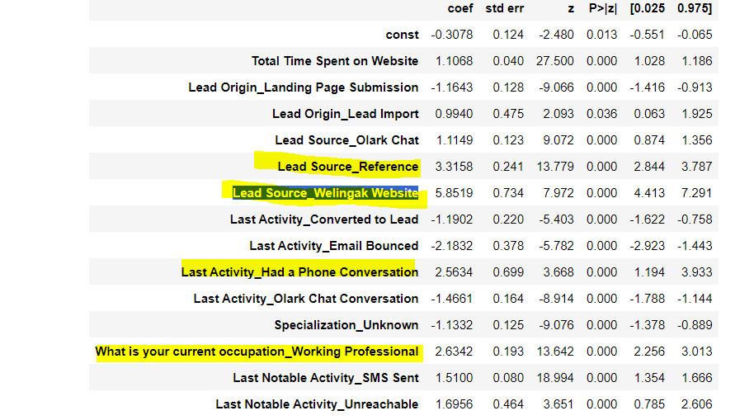

1. What are the top 3 categorical/dummy variables in the model which should be focused the most on in order to increase the probability of lead conversion?

We used the following categorical variables and converted them to dummies   
**'Lead Origin', 'Lead Source', 'Last Activity', 'Specialization’, ‘What is your current occupation’, ‘City’, ‘Last Notable Activity'.**By looking at the final model, following variables should be focused the most in order to increase the probability of lead conversion

**'What is your current occupation', 'Lead Source', 'Last Activity'.**

1. X Education has a period of 2 months every year during which they hire some interns. The sales team, in particular, has around 10 interns allotted to them. So, during this phase, they wish to make the lead conversion more aggressive. So, they want almost all of the potential leads (i.e. the customers who have been predicted as 1 by the model) to be converted and hence, want to make phone calls to as much of such people as possible. Suggest a good strategy they should employ at this stage.

1. Filter out all customers who have been predicted 1 by the model.
2. Based on the lead score that is assigned to them categorize the data into **High, Medium and Low**
3. Contact all the high probability customers first and try to convert the lead followed by the medium and low ones.
4. We can deploy a senior sales member with more experience to contact the High probability ones and for the medium and low we can deploy interns where in the priority is given to the medium category over the low probability ones.
5. Similarly, at times, the company reaches its target for a quarter before the deadline. During this time, the company wants the sales team to focus on some new work as well. So, during this time, the company’s aim is to not make phone calls unless it’s extremely necessary, i.e. they want to minimize the rate of useless phone calls. Suggest a strategy they should employ at this stage.

At this stage, X education should focus on Email-Marketing like setting up free demo sessions for potential leads and collecting the data of the people who joined such sessions.

It’s also important to have minimal phone calls at this point, so have very high value discussions with the candidates who only joined the sessions and try to provide any discounts to convert them to join and improve your target score.